The Law of Readiness
The "Get Ready" Rule
- Learning starts with your mindset. When you are mentally prepared and genuinely motivated to learn, the entire process feels natural and rewarding. However, if you are forced to learn something when you are tired, distracted, or unwilling, the experience becomes frustrating and ineffective. Simply put, you have to be "in the zone" to make learning stick.
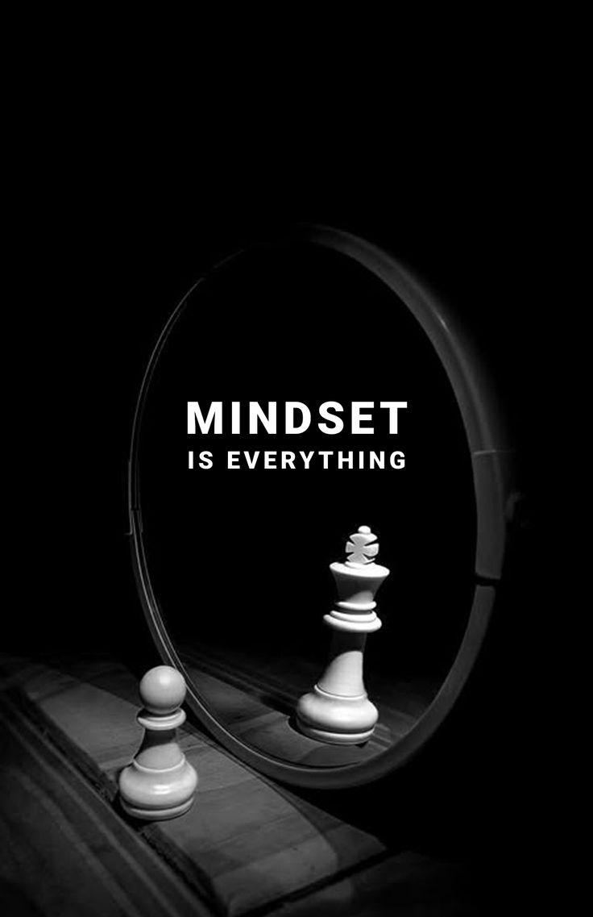

The Law of Exercise
The "Practice Makes Improvement" Rule
- This law is all about the power of repetition. Every time you practice a skill or repeat an action, your brain strengthens the connection for that task, making it easier and more automatic over time. On the other hand, if you stop practicing, that connection fades away, and the skill eventually becomes "rusty." Consistency is the key to mastery.


The Law of Effect
The "Repeat the Winners" Rule
- We are naturally wired to repeat actions that lead to good outcomes. When a behavior is followed by a reward, a win, or a feeling of success, your brain logs that as a positive experience, making you much more likely to repeat it in the future. Conversely, if an action leads to a bad result or failure, we instinctively learn to avoid that path. We stick with what works.
